# Controlling the Ship

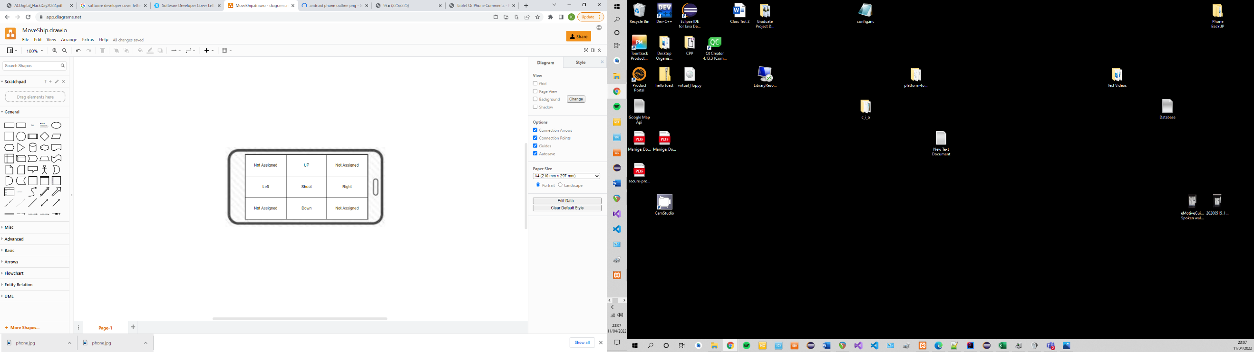The user must be able to direct the ship and shoot at the enemy. Having clear and easy to use controls is imperative for successful gameplay. The game has been designed so that it will only ever display the game in landscape. The screen was divided into 9 sections using a 3x3 grid. 5 of the sections are functional: Up, Down, Left, Right, and Centre. The centre section allows for the user to fire a bullet, while the other sections direct the spaceship accordingly.

The sections not assigned could be implemented in the future to allow the user to move in diagonal directions.